Ford TOURNEO CONNECT/GRAND TOURNEO CONNECT – PRELIMINARY Specifications

Fuel CONSUMPTION AND PERFORMANCE

 |  |  | Fuel consumption  l/100km (mpg) |  |  | Performance
Engine | Power  (PS) | CO₂  (g/km) | Urban | Extra  Urban | Combined | Max  Speed  (km/h) | 0-100 km/h (secs) | 80-120 km/h** (secs)
Tourneo Connect
1.6 Duratorq TDCi (5-sp man)  with FE pack* | 75 | 120 | 4.9 (57.6) | 4.4 (64.2) | 4.6 (61.4) | 145 | 17.8 | 25.3
1.6 Duratorq TDCi (5-sp man) | 75 | 130 | 5.6 (50.4) | 4.6 (61.4) | 5.0 (56.5) | 145 | 17.8 | 25.7
1.6 Duratorq TDCi (5-sp man)  with FE pack | 95 | 120 | 4.9 (57.6) | 4.4 (64.2) | 4.6 (61.4) | 160 | 14.7 | 21.2
1.6 Duratorq TDCi (5-sp man) | 95 | 130 | 5.6 (50.4) | 4.6 (61.4) | 5.0 (56.5) | 160 | 14.7 | 21.6
1.6 Duratorq TDCi (6-sp man) | 115 | 130 | 5.6 (50.4) | 4.6 (61.4) | 4.9 (57.6) | 165 | 13.8 | 15.1
1.0 EcoBoost (6-sp man) | 100 | 129 | 6.4 (44.1) | 5.1 (55.4) | 5.6 (50.4) | 165 | 14.0 | 20.0
1.6 EcoBoost (6-sp auto) | 150 | 184 | 10.9 (25.9) | 6.3 (44.8) | 8.0 (35.3) | 173 | 10.9 | -
Grand Tourneo Connect
1.6 Duratorq TDCi (5-sp man)  with FE pack | 75 | 121 | 4.9 (57.6) | 4.5 (62.8) | 4.6 (61.4) | 145 | 18.3 | 26.4
1.6 Duratorq TDCi (5-sp man) | 75 | 130 | 5.6 (50.4) | 4.6 (61.4) | 5.0 (56.5) | 145 | 18.3 | 26.8
1.6 Duratorq TDCi (5-sp man)  with FE pack | 95 | 121 | 4.9 (57.6) | 4.5 (62.8) | 4.6 (61.4) | 160 | 15.1 | 22.0
1.6 Duratorq TDCi (5-sp man) | 95 | 130 | 5.6 (50.4) | 4.6 (61.4) | 5.0 (56.5) | 160 | 15.1 | 22.4
1.6 Duratorq TDCi (6-sp man) | 115 | 130 | 5.6 (50.4) | 4.6 (61.4) | 4.9 (57.6) | 165 | 14.1 | 15.6
1.6 EcoBoost (6-sp auto) | 150 | 184 | 10.9 (25.9) | 6.3 (44.8) | 8.0 (35.3) | 173 | 11.1 | -

* Fuel Economy pack includes Auto-Start-Stop, Active Grille Shutter, Smart Regenerative Charging
** In 5th gear

WEIGHTS AND DIMENSIONS

Weights

 | Kerbweight (kg)# | Gross Vehicle Mass (kg) | Gross Train Mass (kg) | Max. Towable Mass (braked) (kg) | Max. Towable Mass (unbraked) (kg)
Tourneo Connect
1.0 EcoBoost | 1420 | 2010 | 2910 | 1000 | 745
1.6 EcoBoost | 1469 | 2045 | 2945 | 1000 | 750
1.6 Duratorq 75 PS | 1458 | 2045 | 2945 | 1000 | 750
1.6 Duratorq 95 PS | 1458 | 2045 | 3145 | 1200 | 750
1.6 Duratorq 115 PS | 1467 | 2055 | 3155 | 1200 | 750
Grand Tourneo Connect - 7 seats
1.6 EcoBoost | 1523 | 2320 | 2920 | 750 | 750
1.6 Duratorq 75 PS | 1512 | 2300 | 2945 | 800 | 750
1.6 Duratorq 95 PS | 1512 | 2300 | 3145 | 1000 | 750
1.6 Duratorq 115 PS | 1521 | 2310 | 3155 | 1000 | 750

^{Ø}Payload = Gross vehicle mass, less kerb mass. All kerb masses quoted are subject to manufacturing tolerances and are for base models with minimum equipment.
^{u}Represents the lightest kerbweight assuming full fluid levels and 90% fuel levels, subject to manufacturing tolerances and options, etc, fitted.

Dimensions

 | Tourneo Connect | Grand Tourneo  Connect 5-seat | Grand Tourneo Connect 7-seat
Overall length | 4418 | 4818 | 4818
Overall width with mirrors | 2137 | 2137 | 2137
Overall height | 1852 | 1845 | 1840
Side door entry width | 612 | 839 | 839
Luggage space width between wheel arches | 1192 | 1149 | 1149
Luggage space width | 1477 | 1477 | 1477
Luggage floor to roof | 1245 | 1234 | 1072
Luggage space length 2 seat mode | 1800 | 2179 | 2179
Luggage space length 5 seat mode | 913 | 1305 | 1264
Luggage space length 7 seat mode | n/a | n/a | 450
Luggage capacity (litres)‡
Luggage Capacity 2 seat mode | 2410 | 2761 | 2620
Luggage Capacity 5 seat mode | 1029 | 1529 | 1287
Luggage Capacity 7 seat mode | n/a | n/a | 322

BODY AND CHASSIS

Body Structure | Computer-optimised, high-efficiency, unitary-welded steel body incorporating rigid occupant cell and front and rear energy-absorbing crumple zones; direct-glazed windshield.
Passive safety and restraint system elements | Integrated passive safety system featuring:  - Driver and passenger airbags plus thorax-protecting side airbags for front occupants  - Side curtain airbags for front and second row (Tourneo Connect), Side curtain airbags for front, second and third row (Grand Tourneo Connect).  - Three-point safety belts in all positions. Front seat belts are specified with outboard pre-tensioners as standard.  - Safety belt reminders for driver and front passenger  - ISOFIX child seat attachment points on the 2 outer seats in the second row
Corrosion protection | Multi-stage paint and body protection process, including zinc precoating for all relevant exterior panels, optimised dip phosphate coat, electrocoat primer, primer/surfacer and basecoat/clearcoat system, plus comprehensive cavity wax injection, PVC underbody coating and stone chip protection. Thick PVC sealing beads for flanges. Front plastic wheel arch liners, rear textile wheel arch liners, anti scuff strips on inner doorsills.
Suspension | Front – Independent MacPherson struts with offset coil spring over gas filled damper units and lower L-arms with optimised front rubber bushings and rear bush mounted on separate reinforced cross-member sub-frame, anti roll bar.
 | Rear – Torsion beam rear suspension with coil springs and monotube damper units.
Steering | Type – Rack and pinion steering with rack-mounted Electric Power Assisted Steering (EPAS)
Turning circle (Kerb-to-Kerb) – 11.3m (L1), 12.2m (L2)
Turning circle (Wall-to-Wall) – 11.7m (L1), 12.5m (L2)

 | Turns lock-to-lock – 2.7
Brakes | Dual circuit, diagonally split, hydraulically operated disc brakes front and rear. Vacuum servo assisted with four-channel ABS and electronic brake distribution (EBD)
Brake disc dimensions (front/ventilated discs):
300mm diameter (Tourneo Connect)
320mm diameter (Grand Tourneo Connect)
Brake disc dimensions (rear/solid discs):
280mm diameter

Modulation:
ABS, Traction Control, ESC, EBD, Emergency Brake Assist (EBA), Load Adaptive Control (LAC), Hill Start Assist (HSA), Trailer Sway Control (TSC), Emergency Brake Light (EBL), Torque Vectoring Control (TVC)
Optional Active City Stop system

Wheels and tyres
Wheel type | Pressed Steel | Alloy
Wheel size | 6.5 x 16” | 6.5 x 16”
Tyre size | 205/60 R 16 | 205/60 R 16
Spare wheel and tyre | Full-sized spare or Tyre Mobility Kit (varies by market and vehicle specification)

PETROL ENGINES

 |  | 1.0-litre EcoBoost  (100PS) |  | 1.6-litre EcoBoost  (150PS)
Type |  | Inline three cylinder turbo petrol, direct fuel injection and Ti-VCT, transverse |  | Inline four cylinder turbo petrol, direct fuel injection and Ti-VCT, transverse
Displacement | cm³ | 999 |  | 1597
Bore | mm | 71.9 |  | 79.0
Stroke | mm | 82.0 |  | 81.4
Compression ratio |  | 10.0:1 |  | 10.0:1
Max power | PS (kW) | 100 (74) |  | 150 (110)
 | at rpm | 6000 |  | 5700
Max torque | Nm | 170 |  | 240
 | at rpm | 1400-4000 |  | 1600—4000
Valve gear |  | DOHC with 4 valves per cylinder,  twin independent variable cam timing |  | DOHC with 4 valves per cylinder,  twin independent variable cam timing
Cylinders |  | 3 in line |  | 4 in line
Cylinder head |  | Cast aluminium |  | Cast aluminium
Cylinder block |  | Cast iron |  | Cast aluminium
Camshaft drive |  | Low friction Belt-in-Oil with dynamic tensioner |  | Timing belt with dynamic tensioner
Crankshaft |  | Cast iron, 6 counterweights, 4 main bearings |  | Cast iron, 4 counterweights, 5 main bearings
Engine management |  | Bosch MED17 with CAN-Bus and individual cylinder knock control |  | Bosch MED17 with CAN-Bus and individual cylinder knock control
Fuel injection |  | High pressure direct fuel injection with 6 hole injectors |  | High pressure direct fuel injection with 6 hole injectors
Emission level |  | Euro Stage 5 |  | Euro Stage 5
Turbocharger |  | Continental low inertia turbo |  | Borg Warner KP39 low inertia turbo
Lubrication system |  | Electronically controlled variable displacement oil pump for improved fuel economy |  | Electronically controlled variable displacement oil pump for improved fuel economy
System capacity with filter | litres | 4.1 |  | 4.1
Cooling system |  | Split cooling system with 2 thermostats |  | Water pump with thermostat and valves
System capacity incl heater | litres | 5.5 |  | 5.5
Transmission |  | Durashift 6-speed (B6) manual |  | 6F35 6-speed automatic transmission
Gear ratios
 |  | 6th 0.683  5th 0.844  4th 0.780  3rd 1.121  2nd 1.864  1st 3.727  Reverse 3.625  Final Drive 4.27 |  | 6th 0.746  5th 1.000  4th 1.446  3rd 1.912  2nd 2.964  1st 4.584  Reverse 2.943  Final Drive 3.066

Power Curves

1.0-litre EcoBoost 100PS (74kW)

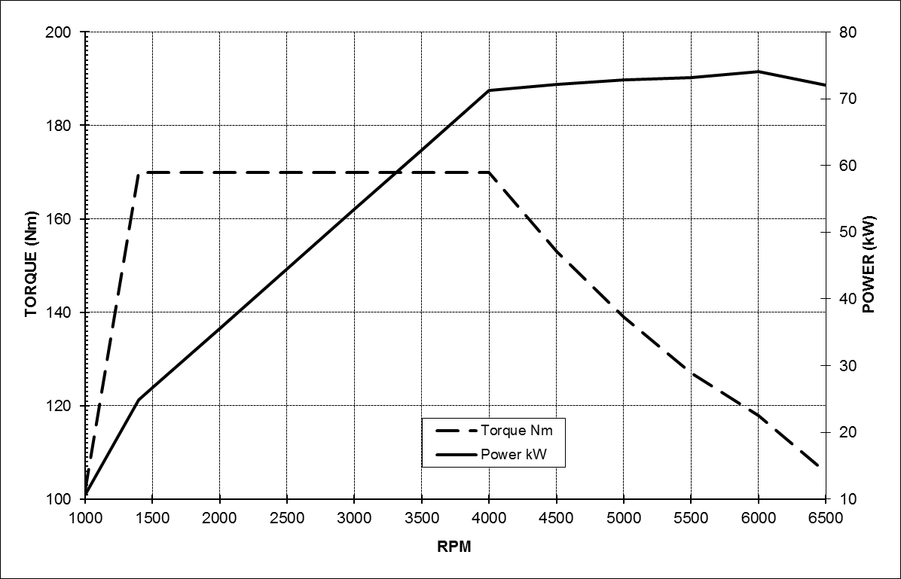

1.6-litre EcoBoost 150PS (110kW)

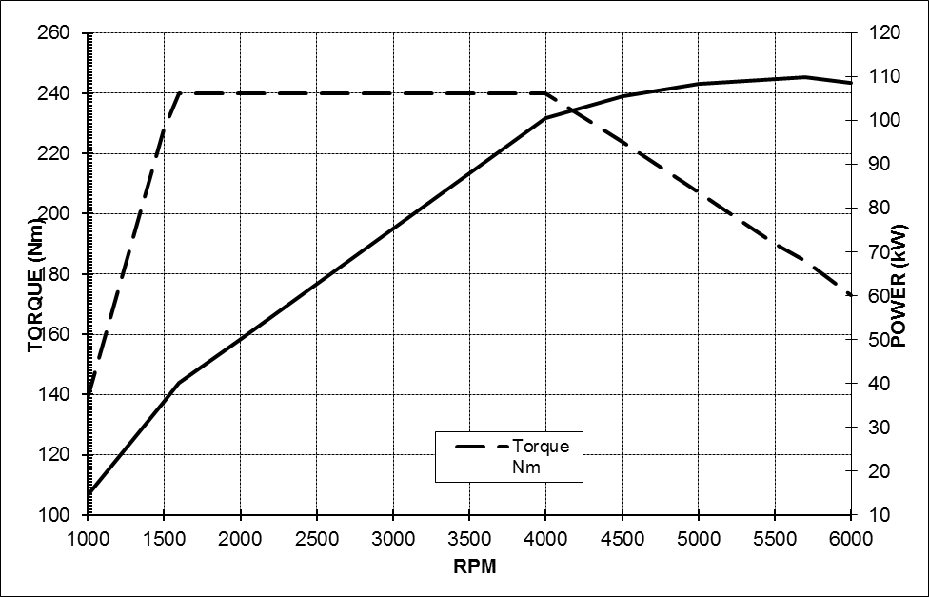

DIESEL ENGINE

1.6-litre Duratorq TDCi
(95PS)
Type |  | Inline four cylinder turbo diesel, transverse
Displacement | cm³ | 1560
Bore | mm | 75.0
Stroke | mm | 88.3
Compression ratio |  | 16.0:1
Max power | PS (kW) | 75 (55) | 95 (70) | 115 (85)
 | at rpm | 3500 | 3600 | 3600
Max torque | Nm | 220 | 230 | 270
 | at rpm | 1500 | 1500—2000 | 1750—2500
Valve gear |  | SOHC  with 2 valves per cylinder
Cylinders |  | 4 in line
Cylinder head |  | Cast aluminium
Cylinder block |  | Cast aluminium
Camshaft drive |  | Timing belt with dynamic tensioner
Crankshaft |  | Drop forged steel, 8 counter- weights, 5 main bearings
Engine management |  | Ford Common Rail Diesel Engine Management System
Fuel injection |  | Common rail direct fuel inj; 1650 bar injection pressure; 7-hole piezo-electric injectors
Emission control |  | Oxidation catalyst, water cooled EGR and standard cDPF
Emission level |  | Euro Stage 5
Turbocharger |  | Garrett variable geometry turbocharger
Lubrication system |  | Pressure-fed lubrication system with full flow oil filter
System capacity | litres | 3.8 with filter
Cooling system |  | Water pump with thermostat and valves, with thermal management system
System capacity | litres | 5.8 incl heater
Transmission |  | Durashift 5-speed (MTX75) manual |  |  | Durashift 6-speed (MMT6) manual
Gear ratios
 |  | 5th 0.674  4th 0.865  3rd 1.258  2nd 2.048  1st 3.800  Reverse 3.727  Final Drive 3.56 | 5th 0.674  4th 0.865  3rd 1.258  2nd 2.048  1st 3.800  Reverse 3.727  Final Drive 3.56 (Econetic 3.41) | 6th 0.789  5th 0.943  4th 0.868  3rd 1.194  2nd 1.864  1st 3.583  Reverse 3.615  Final Drive 3.69

Power Curves

1.6-litre Duratorq TDCi 75PS (55kW)

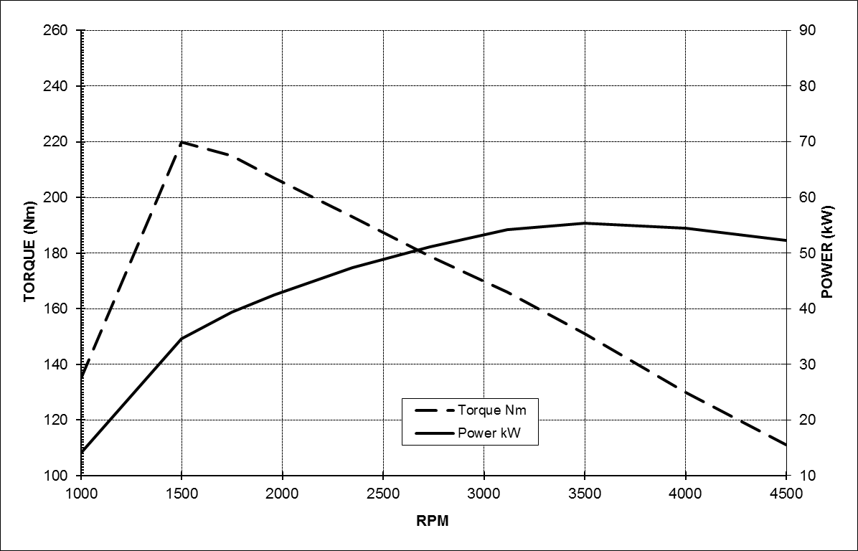

1.6-litre Duratorq TDCi 95PS (70kW)

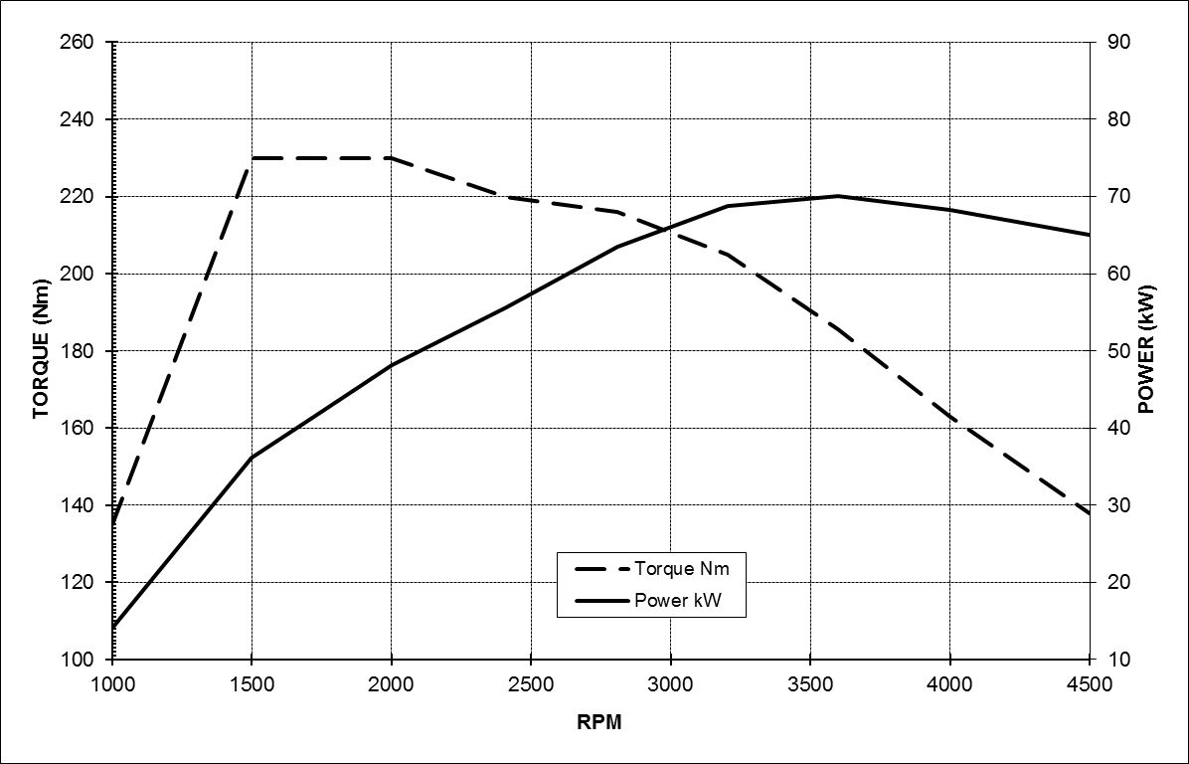

1.6-litre Duratorq TDCi 115PS (85kW)

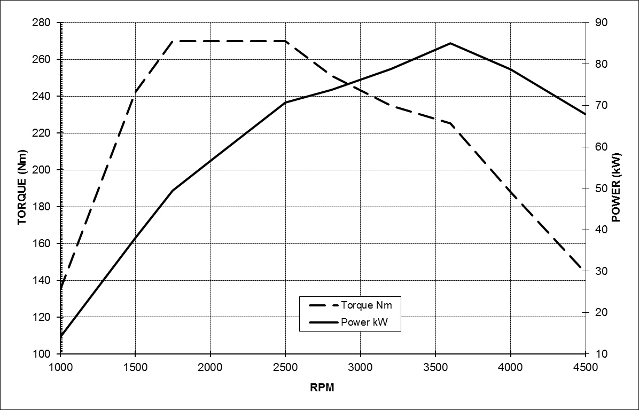

* The stated fuel consumption and CO₂ emissions are measured according to the technical requirements and specifications of the European Regulation (EC) 715/2007 as last amended. Results in MPG also correspond to this European drive cycle and are stated in imperial gallons. The results may differ from fuel economy figures in other regions of the world due to the different drive cycles and regulations used in those markets

Note: The data information in this press release reflects preliminary specifications and was correct at the time of going to print. However, Ford policy is one of continuous product improvement. The right is reserved to change these details at any time.

About Ford Motor Company
Ford Motor Company, a global automotive industry leader based in Dearborn, Mich., manufactures or distributes automobiles across six continents. With about 175,000 employees and 65 plants worldwide, the company’s automotive brands include Ford and Lincoln. The company provides financial services through Ford Motor Credit Company. For more information regarding Ford’s products, please visit www.ford.com.

Ford Europe is responsible for producing, selling and servicing Ford brand vehicles in 50 individual markets and employs approximately 47,000 employees at its wholly owned facilities and approximately 69,000 people when joint ventures and unconsolidated businesses are included. In addition to Ford Motor Credit Company, Ford Europe operations include Ford Customer Service Division and 24 manufacturing facilities (15 wholly owned or consolidated joint venture facilities and nine unconsolidated joint venture facilities). The first Ford cars were shipped to Europe in 1903 – the same year Ford Motor Company was founded. European production started in 1911.

Contacts: | Detlef Jenter
 | Ford of Europe
 | +49 221 901 8745
 | djenter@ford.com

