Ford TRANSIT CONNECT – PRELIMINARY Specifications

Fuel CONSUMPTION

Fuel consumption
l/100km (mpg)
Engine | Power  (PS) | CO₂  (g/km) | Urban | Extra Urban | Combined
Transit Connect Van L1
1.6 Duratorq TDCi (5-sp man) with FE pack* | 75 | 115 | 4.8 (58.9) | 4.2 (67.3) | 4.4 (64.2)
1.6 Duratorq TDCi (5-sp man) | 75 | 124 | 5.5 (51.4) | 4.3 (65.7) | 4.8 (58.9)
1.6 Duratorq TDCi (5-sp man) with FE pack | 95 | 115 | 4.8 (58.9) | 4.2 (67.3) | 4.4 (64.2)
1.6 Duratorq TDCi (5-sp man) | 95 | 124 | 5.5 (51.4) | 4.3 (65.7) | 4.8 (58.9)
1.6 Duratorq TDCi ECOnetic** (5-sp man) | 95 | 105 | 4.5 (62.8) | 3.7 (76.3) | 4.0 (70.6)
1.6 Duratorq TDCi (6-sp man) | 115 | 124 | 5.5 (51.4) | 4.3 (65.7) | 4.8 (58.9)
1.0 EcoBoost (6-sp man) | 100 | 129 | 6.4 (44.1) | 5.1 (55.4) | 5.6 (50.4)
1.6 EcoBoost (6-sp auto) | 150 | 179 | 10.8 (26.2) | 5.9 (47.9) | 7.7 (36.7)
Transit Connect Van L2
1.6 Duratorq TDCi (5-sp man) with FE pack | 75 | 119 | 5.0 (56.5) | 4.3 (65.7) | 4.6 (61.4)
1.6 Duratorq TDCi (5-sp man) | 75 | 128 | 5.5 (51.4) | 4.5 (62.8) | 4.9 (57.6)
1.6 Duratorq TDCi (5-sp man) with FE pack | 95 | 119 | 5.0 (56.5) | 4.3 (65.7) | 4.6 (61.4)
1.6 Duratorq TDCi (5-sp man) | 95 | 128 | 5.5 (51.4) | 4.5 (62.8) | 4.9 (57.6)
1.6 Duratorq TDCi ECOnetic** (5-sp man) | 95 | 108 | 4.7 (60.1) | 3.8 (74.3) | 4.1 (68.9)
1.6 Duratorq TDCi (6-sp man) | 115 | 128 | 5.7 (49.6) | 4.4 (64.2) | 4.9 (57.6)
1.0 EcoBoost (6-sp man) | 100 | 129 | 6.4 (44.1) | 5.1 (55.4) | 5.6 (50.4)
1.6 EcoBoost (6-sp auto) | 150 | 184 | 10.9 (25.9) | 6.3 (44.8) | 8.0 (35.3)
Transit Connect Kombi***/DCiV L1
1.6 Duratorq TDCi (5-sp man) with FE pack | 75 | 119 | 5.0 (56.5) | 4.3 (65.7) | 4.6 (61.4)
1.6 Duratorq TDCi (5-sp man) | 75 | 128 | 5.5 (51.4) | 4.5 (62.8) | 4.9 (57.6)
1.6 Duratorq TDCi (5-sp man) with FE pack | 95 | 119 | 5.0 (56.5) | 4.3 (65.7) | 4.6 (61.4)
1.6 Duratorq TDCi (5-sp man) | 95 | 128 | 5.5 (51.4) | 4.5 (62.8) | 4.9 (57.6)
Transit Connect Kombi***/DCiV L2
1.6 Duratorq TDCi (5-sp man) with FE pack | 75 | 119 | 5.0 (56.5) | 4.3 (65.7) | 4.6 (61.4)
1.6 Duratorq TDCi (5-sp man) | 75 | 128 | 5.5 (51.4) | 4.5 (62.8) | 4.9 (57.6)
1.6 Duratorq TDCi (5-sp man) with FE pack | 95 | 119 | 5.0 (56.5) | 4.3 (65.7) | 4.6 (61.4)
1.6 Duratorq TDCi (5-sp man) | 95 | 128 | 5.5 (51.4) | 4.5 (62.8) | 4.9 (57.6)

* Fuel Economy pack includes Auto-Start-Stop, Active Grille Shutter, Smart Regenerative Charging
** Fitted with 100kph speed limiter
*** Figures for Kombi vehicles refer to N1; Kombi vehicles with M1 homologation deliver slightly different results.

WEIGHTS AND DIMENSIONS

Weights
 | Gross payload (kg)^{Ø} | Gross vehicle mass (kg) | Kerb mass (kg)^{u} | Front axle plated mass (kg) | Front axle kerb mass (kg) | Rear axle plated mass (kg) | Rear axle kerb mass (kg) | Trailer Plate (kg) braked  (unbraked) | Max. GTM (kg)
200 L1 Transit Connect
1.0 EcoBoost | 628 | 1970 | 1342 | 1125 | 777 | 1050 | 564 | 1200 (705) | 2875
1.6 EcoBoost | 634 | 2025 | 1391 | 1125 | 832 | 1050 | 559 | 1200 (730) | 2925
1.6 Duratorq 75 PS | 625 | 2005 | 1380 | 1125 | 819 | 1050 | 561 | 1200 (725) | 2905
1.6 Duratorq 95PS ECO | 644 | 2015 | 1371 | 1125 | 823 | 1050 | 548 | N/A | N/A
1.6 Duratorq 95 PS | 625 | 2005 | 1380 | 1125 | 821 | 1050 | 561 | 1200 (725) | 3155
1.6 Duratorq 115 PS | 626 | 2015 | 1389 | 1125 | 832 | 1050 | 557 | 1200 (730) | 3165
220 L1 Transit Connect High Payload
1.6 Duratorq 75 PS | 825 | 2215 | 1390 | 1125 | 824 | 1250 | 566 | 1200 (730) | 2915
1.6 Duratorq 95 PS | 825 | 2215 | 1390 | 1125 | 824 | 1250 | 566 | 1200 (730) | 3165
1.6 Duratorq 115 PS | 831 | 2230 | 1399 | 1125 | 837 | 1250 | 563 | 1200 (735) | 3180
220 L1 Transit Connect DCiV High Payload
1.6 Duratorq 75 PS | 725 | 2230 | 1505 | 1125 | 880 | 1250 | 624 | 1200 (750) | 2930
1.6 Duratorq 95 PS | 725 | 2230 | 1505 | 1125 | 880 | 1250 | 624 | 1200 (750) | 3180
220 L1 Transit Connect Kombi High Payload
1.6 Duratorq 75 PS | 708 | 2220 | 1512 | 1125 | 885 | 1250 | 628 | 1175 (750) | 2920
1.6 Duratorq 95 PS | 708 | 2220 | 1512 | 1125 | 885 | 1250 | 628 | 1200 (750) | 3170
210 L2 Transit Connect
1.0 EcoBoost | 714 | 2085 | 1371 | 1175 | 813 | 1125 | 558 | 1200 (720) | 2935
1.6 Duratorq 75 PS | 715 | 2125 | 1410 | 1175 | 855 | 1125 | 555 | 1200 (740) | 2925
1.6 Duratorq 95PS ECO | 706 | 2125 | 1419 | 1175 | 864 | 1125 | 555 | N/A | N/A
1.6 Duratorq 95 PS | 715 | 2125 | 1410 | 1175 | 855 | 1125 | 555 | 1200 (740) | 3175
1.6 Duratorq 115 PS | 716 | 2135 | 1419 | 1175 | 868 | 1125 | 551 | 1200 (745) | 3185
230 L2 Transit Connect High Payload
1.6 EcoBoost | 911 | 2335 | 1424 | 1225 | 873 | 1300 | 552 | 1200 (745) | 2935
1.6 Duratorq 95 PS | 1003 | 2395 | 1392 | 1225 | 853 | 1355 | 539 | 1200 (730) | 3195
1.6 Duratorq 115 PS | 1004 | 2405 | 1401 | 1225 | 866 | 1355 | 535 | 1200 (735) | 3205
230 L2 Transit Connect DCiV High Payload
1.6 Duratorq 75 PS | 716 | 2270 | 1554 | 1175 | 909 | 1275 | 645 | 1150 (750) | 2940
1.6 Duratorq 95 PS | 716 | 2270 | 1554 | 1175 | 909 | 1275 | 645 | 1200 (750) | 3140
230 L2 Transit Connect Kombi High Payload
1.6 Duratorq 75 PS | 770 | 2270 | 1500 | 1175 | 852 | 1275 | 648 | 1140 (750) | 2940
1.6 Duratorq 95 PS | 770 | 2270 | 1500 | 1175 | 852 | 1275 | 648 | 1200 (750) | 3140
L2 Transit Connect Kombi 7-Seater
1.6 Duratorq 75 PS | 788 | 2300 | 1512 | 1175 | 885 | 1240 | 627 | 800 (750) | 2945
1.6 Duratorq 95 PS | 788 | 2300 | 1512 | 1175 | 885 | 1240 | 627 | 1000 (750) | 3145

^{Ø}Payload = Gross vehicle mass, less kerb mass. All kerb masses quoted are subject to manufacturing tolerances and are for base models with minimum equipment and no spare wheel. ^{u}Represents the lightest kerbweight assuming full fluid levels and 90% fuel levels, subject to manufacturing tolerances and options, etc, fitted.
Dimensions

(Dimensions in mm unless stated) | Transit Connect L1 | Transit Connect L2 | Transit Connect DCiV L1 | Transit Connect DCiV L2 | Transit Connect Kombi L1 | Transit Connect Kombi L2 | Transit Connect Kombi L2 7 Seater
Overall length | 4418 | 4818 | 4418 | 4818 | 4418 | 4818 | 4818
Overall width without mirrors | 1835 | 1835 | 1835 | 1835 | 1835 | 1835 | 1835
Overall width with mirrors | 2137 | 2137 | 2137 | 2137 | 2137 | 2137 | 2137
Overall height (unladen) | 1861 | 1862 | 1836 | 1839 | 1836 | 1845 | 1840
Front overhang | 878 | 878 | 878 | 878 | 878 | 878 | 878
Wheelbase | 2662 | 3062 | 2662 | 3062 | 2662 | 3062 | 3062
Rear overhang | 878 | 878 | 878 | 878 | 878 | 878 | 878
Side door entry width | n/a | n/a | 612 | 839 | 612 | 839 | 839
Side door entry width (with bulkhead) | 433 | 660 | n/a | n/a | n/a | n/a | n/a
Rear door opening width below belt | 1248 | 1248 | n/a | n/a | n/a | n/a | n/a
Rear door opening width max | n/a | n/a | 1248 | 1248 | 1248 | 1193 | 1193
Loadspace width between wheel arches | 1226 | 1226 | 1226 | 1226 | 1226 | 1149 | 1149
Rear door opening height | 1136 | 1136 | 1136 | 1136 | 1146 | 1146 | 1146
Loadspace width at floor | 1538 | 1538 | n/a | n/a | n/a | n/a | n/a
Loadspace width | n/a | n/a | 1268 | 1268 | 1268 | 1477 | 1477
Side door opening height | 1228 | 1228 | 1228 | 1228 | 1228 | 1141 | 1141
Loadspace floor to roof | 1269 | 1269 | 1237 | 1267 | 1237 | 1226 | 1066
Loadspace length (max) (to bulkhead) | 1753 | 2153 | n/a | n/a | n/a | n/a | n/a
Loadspace length (laden to belt line) | 1558 | 1958 | n/a | n/a | n/a | n/a | n/a
Loadspace length (laden to belt line, to back of front seat) | n/a | n/a | n/a | n/a | 1800 | 1947 | 1947
Loadspace length (at floor) | n/a | n/a | 845 | 1072 | 913 | n/a | n/a
Loadspace length (back of front seat, at floor) | n/a | n/a | n/a | n/a | n/a | 2179 | 2179
Loadspace length max (with load through bulkhead) | 3000 | 3400 | n/a | n/a | n/a | n/a | n/a
Loading height (unladen) | 599 | 599 | 593 | 586 | 593 | 597 | 597
Front track | 1568 | 1568 | 1568 | 1568 | 1568 | 1568 | 1568
Rear track | 1585 | 1585 | 1584 | 1584 | 1584 | 1584 | 1584
Ground clearance | 152 | 159 | 154 | 165 | 154 | 163 | 163
Cargo volume behind bulkhead VDA/SAE | 2.6/2.9m³ | 3.2/3.6m³ | n/a/1.2m³ | n/a/1.6m³ | n/a | n/a | n/a
Cargo Volume (7 seats up) (litres) | n/a | n/a | n/a | n/a | n/a | n/a | 322
Cargo volume (2nd row seat up) (litres) | n/a | n/a | n/a | n/a | 1029 | 1529 | 1287
Cargo volume (2nd row seat folded) (litres) | n/a | n/a | n/a | n/a | 2003 | 2761 | 2620
Cargo volume less bulkhead, with front seat folded SAE | 3.7m³ | 4.4m³ | n/a | n/a | n/a | n/a | n/a

BODY AND CHASSIS

Body Structure | Computer-optimised, high-efficiency, unitary-welded steel body incorporating rigid occupant cell and front and rear energy-absorbing crumple zones; direct-glazed windshield.
Passive safety and restraint system elements | Integrated passive safety system featuring:  - Full size driver’s airbag  - Optional passenger airbag with de-activation switch  - Optional thorax-protecting side airbags for front occupants  - Optional side curtain airbags for front occupants  - Three-point safety belts in all positions. Front seat belts are specified with outboard pre-tensioners as standard.  - Safety belt reminders for driver and front passenger  - ISOFIX child seat attachment points on single front passenger seats (not on dual passenger seat) for vans and on the 2 outer seats in the 2nd row on Kombi models
Corrosion protection | Multi-stage paint and body protection process, including zinc precoating for all relevant exterior panels, optimised dip phosphate coat, electrocoat primer, primer/surfacer and basecoat/clearcoat system, plus comprehensive cavity wax injection, PVC underbody coating and stone chip protection. Thick PVC sealing beads for flanges. Front plastic wheel arch liners, rear textile wheel arch liners, anti scuff strips on inner doorsills.
Suspension | Front – Independent MacPherson struts with offset coil spring over gas filled damper units and lower L-arms with optimised front rubber bushings and rear bush mounted on separate reinforced cross-member sub-frame, anti roll bar.
 | Rear – Torsion beam rear suspension with coil springs and monotube damper units.
Steering | Type – Rack and pinion steering with rack-mounted Electric Power Assisted Steering (EPAS)
Turning circle (Kerb-to-Kerb) – 11.3m (L1), 12.2m (L2)
Turning circle (Wall-to-Wall) – 11.7m (L1), 12.5m (L2)

 | Turns lock-to-lock – 2.7
Brakes | Dual circuit, diagonally split, hydraulically operated disc brakes front and rear. Vacuum servo assisted with four-channel ABS and electronic brake distribution (EBD)
Brake disc dimensions (front/ventilated discs):
300mm diameter (low payload models)
320mm diameter (high payload models)
Brake disc dimensions (rear/solid discs):
280mm diameter

Modulation:
ABS, Traction Control, ESC, EBD, Emergency Brake Assist (EBA), Load Adaptive Control (LAC), Hill Start Assist (HSA), Trailer Sway Control (TSC), Emergency Brake Light (EBL), Torque Vectoring Control (TVC)
Optional Active City Stop system
Wheels and tyres
Wheel type | Pressed Steel | Alloy
Wheel size | 6.5 x 16” | 6.5 x 16”
Tyre size | 205/60 R 16 | 205/60 R 16
Spare wheel and tyre | Full-sized spare or Tyre Mobility Kit (varies by market and vehicle specification)

PETROL ENGINES

 |  | 1.0-litre EcoBoost  (100PS) |  | 1.6-litre EcoBoost  (150PS)
Type |  | Inline three cylinder turbo petrol, direct fuel injection and Ti-VCT, transverse |  | Inline four cylinder turbo petrol, direct fuel injection and Ti-VCT, transverse
Displacement | cm³ | 999 |  | 1597
Bore | mm | 71.9 |  | 79.0
Stroke | mm | 82.0 |  | 81.4
Compression ratio |  | 10.0:1 |  | 10.0:1
Max power | PS (kW) | 100 (74) |  | 150 (110)
 | at rpm | 6000 |  | 5700
Max torque | Nm | 170 |  | 240
 | at rpm | 1400-4000 |  | 1600—4000
Valve gear |  | DOHC with 4 valves per cylinder,  twin independent variable cam timing |  | DOHC with 4 valves per cylinder,  twin independent variable cam timing
Cylinders |  | 3 in line |  | 4 in line
Cylinder head |  | Cast aluminium |  | Cast aluminium
Cylinder block |  | Cast iron |  | Cast aluminium
Camshaft drive |  | Low friction Belt-in-Oil with dynamic tensioner |  | Timing belt with dynamic tensioner
Crankshaft |  | Cast iron, 6 counterweights, 4 main bearings |  | Cast iron, 4 counterweights, 5 main bearings
Engine management |  | Bosch MED17 with CAN-Bus and individual cylinder knock control |  | Bosch MED17 with CAN-Bus and individual cylinder knock control
Fuel injection |  | High pressure direct fuel injection with 6 hole injectors |  | High pressure direct fuel injection with 6 hole injectors
Emission level |  | Euro Stage 5 |  | Euro Stage 5
Turbocharger |  | Continental low inertia turbo |  | Borg Warner KP39 low inertia turbo
Lubrication system |  | Electronically controlled variable displacement oil pump for improved fuel economy |  | Electronically controlled variable displacement oil pump for improved fuel economy
System capacity with filter | litres | 4.1 |  | 4.1
Cooling system |  | Split cooling system with 2 thermostats |  | Water pump with thermostat and valves
System capacity incl heater | litres | 5.5 |  | 5.5
Transmission |  | Durashift 6-speed (B6) manual |  | 6F35 6-speed automatic transmission
Gear ratios
 |  | 6th 0.683  5th 0.844  4th 0.780  3rd 1.121  2nd 1.864  1st 3.727  Reverse 3.625  Final Drive 4.27 |  | 6th 0.746  5th 1.000  4th 1.446  3rd 1.912  2nd 2.964  1st 4.584  Reverse 2.943  Final Drive 3.066

Power Curves

1.0-litre EcoBoost 100PS (74kW)

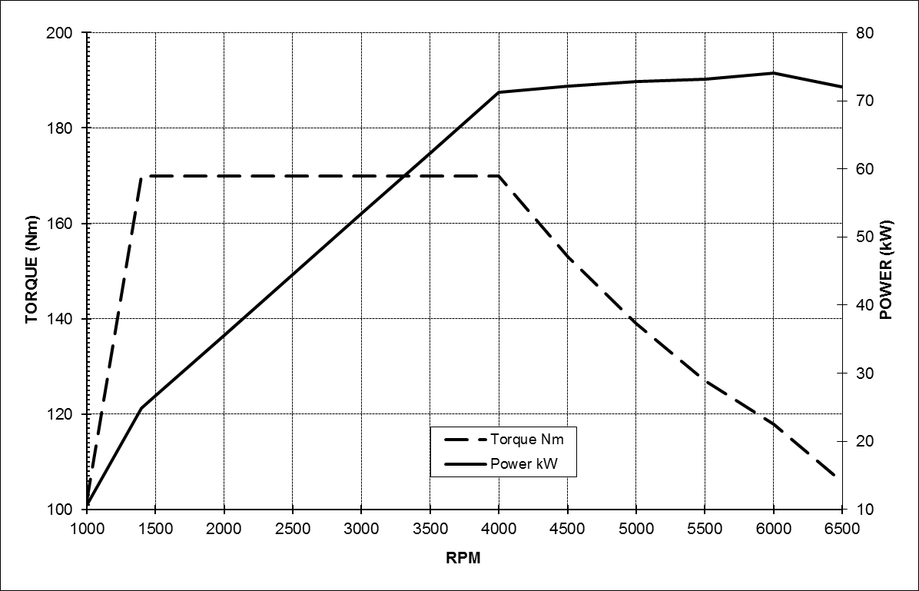

1.6-litre EcoBoost 150PS (110kW)

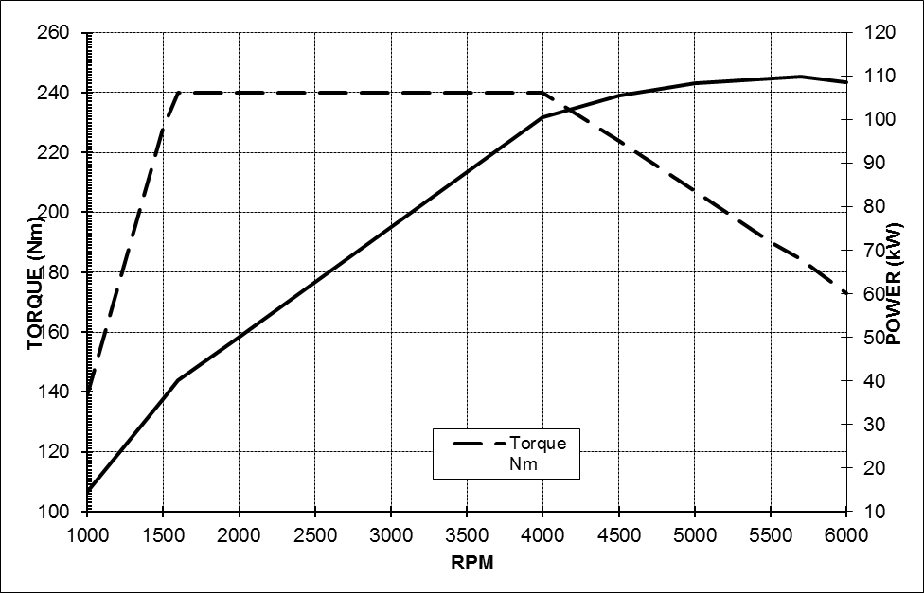

DIESEL ENGINE

1.6-litre Duratorq TDCi
(95PS)
Type |  | Inline four cylinder turbo diesel, transverse
Displacement | cm³ | 1560
Bore | mm | 75.0
Stroke | mm | 88.3
Compression ratio |  | 16.0:1
Max power | PS (kW) | 75 (55) | 95 (70) | 115 (85)
 | at rpm | 3500 | 3600 | 3600
Max torque | Nm | 220 | 230 | 270
 | at rpm | 1500 | 1500—2000 | 1750—2500
Valve gear |  | SOHC  with 2 valves per cylinder
Cylinders |  | 4 in line
Cylinder head |  | Cast aluminium
Cylinder block |  | Cast aluminium
Camshaft drive |  | Timing belt with dynamic tensioner
Crankshaft |  | Drop forged steel, 8 counter- weights, 5 main bearings
Engine management |  | Ford Common Rail Diesel Engine Management System
Fuel injection |  | Common rail direct fuel inj; 1650 bar injection pressure; 7-hole piezo-electric injectors
Emission control |  | Oxidation catalyst, water cooled EGR and standard cDPF
Emission level |  | Euro Stage 5
Turbocharger |  | Garrett variable geometry turbocharger
Lubrication system |  | Pressure-fed lubrication system with full flow oil filter
System capacity | litres | 3.8 with filter
Cooling system |  | Water pump with thermostat and valves, with thermal management system
System capacity | litres | 5.8 incl heater
Transmission |  | Durashift 5-speed (MTX75) manual |  |  | Durashift 6-speed (MMT6) manual
Gear ratios
 |  | 5th 0.674  4th 0.865  3rd 1.258  2nd 2.048  1st 3.800  Reverse 3.727  Final Drive 3.56 | 5th 0.674  4th 0.865  3rd 1.258  2nd 2.048  1st 3.800  Reverse 3.727  Final Drive 3.56 (Econetic 3.41) | 6th 0.789  5th 0.943  4th 0.868  3rd 1.194  2nd 1.864  1st 3.583  Reverse 3.615  Final Drive 3.69

Power Curves

1.6-litre Duratorq TDCi 75PS (55kW)

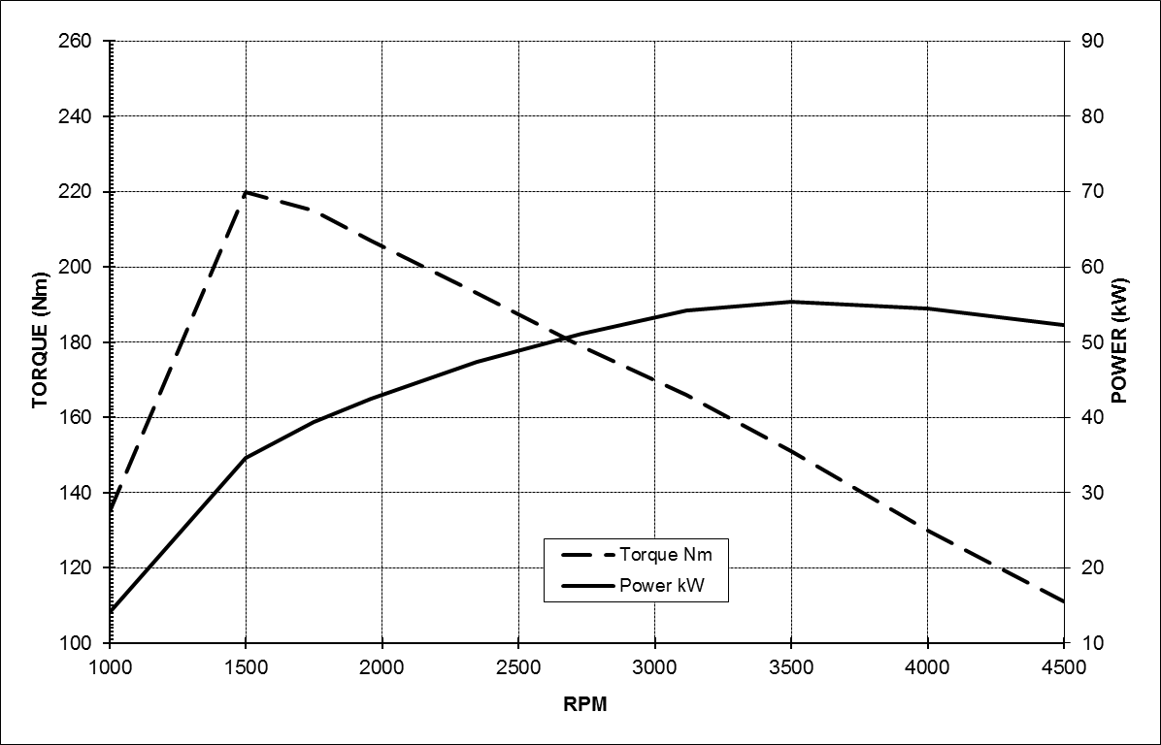

1.6-litre Duratorq TDCi 95PS (70kW)

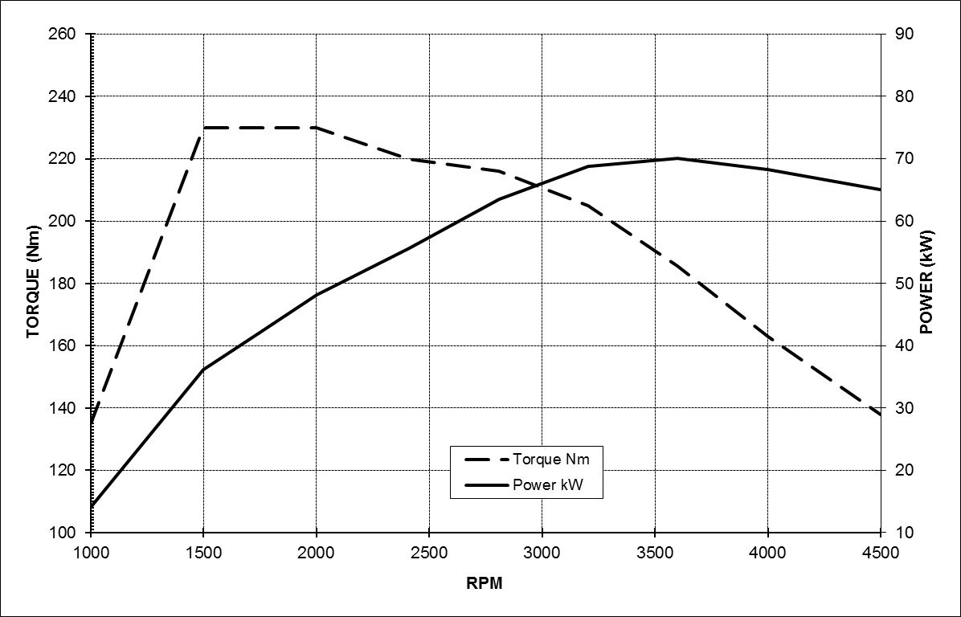

1.6-litre Duratorq TDCi 115PS (85kW)

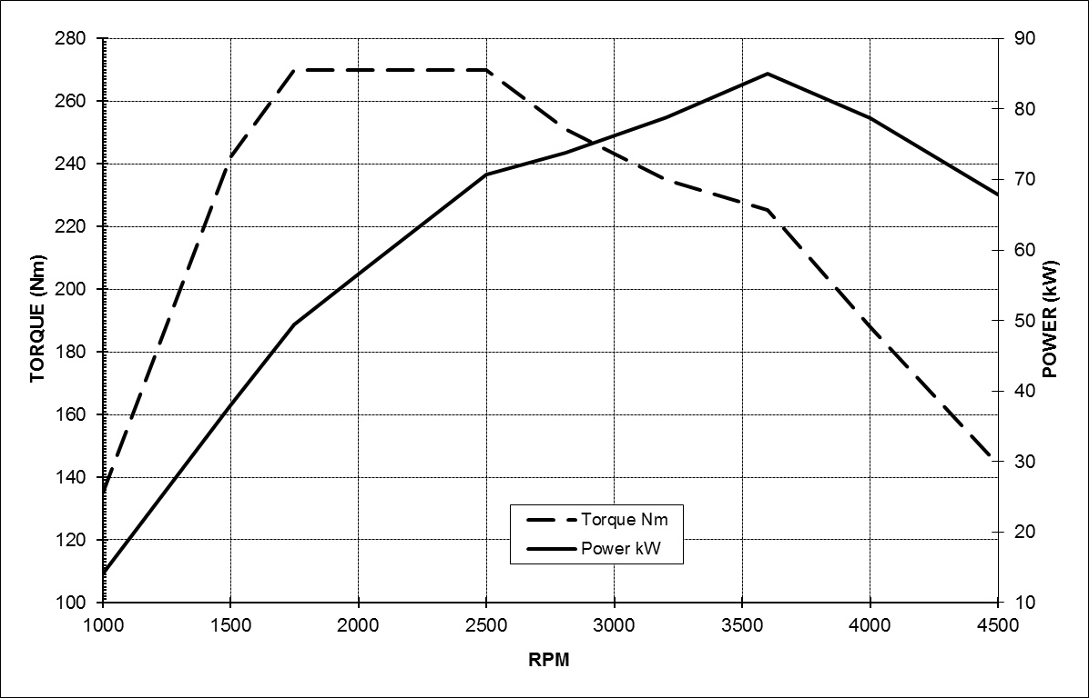

* The stated fuel consumption and CO₂ emissions are measured according to the technical requirements and specifications of the European Regulation (EC) 715/2007 as last amended. Results in MPG also correspond to this European drive cycle and are stated in imperial gallons. The results may differ from fuel economy figures in other regions of the world due to the different drive cycles and regulations used in those markets

Note: The data information in this press release reflects preliminary specifications and was correct at the time of going to print. However, Ford policy is one of continuous product improvement. The right is reserved to change these details at any time.

About Ford Motor Company
Ford Motor Company, a global automotive industry leader based in Dearborn, Mich., manufactures or distributes automobiles across six continents. With about 175,000 employees and 65 plants worldwide, the company’s automotive brands include Ford and Lincoln. The company provides financial services through Ford Motor Credit Company. For more information regarding Ford’s products, please visit www.ford.com.

Ford Europe is responsible for producing, selling and servicing Ford brand vehicles in 50 individual markets and employs approximately 47,000 employees at its wholly owned facilities and approximately 69,000 people when joint ventures and unconsolidated businesses are included. In addition to Ford Motor Credit Company, Ford Europe operations include Ford Customer Service Division and 24 manufacturing facilities (15 wholly owned or consolidated joint venture facilities and nine unconsolidated joint venture facilities). The first Ford cars were shipped to Europe in 1903 – the same year Ford Motor Company was founded. European production started in 1911.

Contacts: | Detlef Jenter
 | Ford of Europe
 | +49 221 901 8745
 | djenter@ford.com

