Ford TRANSIT COURIER – PRELIMINARY Specifications

Performance and Economy

 |  |  | Fuel consumption  l/100 km (mpg) |  |  | Performance
Engine | Power  (PS) | CO₂  (g/km) | Urban | Extra  Urban | Combined | Max speed kph (mph) | 0-100 kph  0-62 mph  (sec) | 50-100 kph  31-62 mph  (sec)*
1.5 TDCi (5-sp man) | 75 | 108 | 4.7 (60.1) | 3.7 (76.3) | 4.1 (68.9) | 157 (98) | 16.0 | 11.5
1.5 TDCi (5-sp man) s/s | 75 | 103 | 4.4 (64.2) | 3.6 (78.5) | 3.9 (72.4) | 157 (98) | 16.0 | 11.5
1.6 TDCi (5-sp man) | 95 | 105 | 4.7 (60.1) | 3.6 (78.5) | 4.0 (70.6) | 170 (106) | 14.0 | 9.8
1.6 TDCi (5-sp man) s/s | 95 | 100 | 4.4 (64.2) | 3.5 (80.7) | 3.8 (74.3) | 170 (106) | 14.0 | 9.8
1.6 TDCi (5-sp man) s/s, 100km/h speed limiter | 95 | 97 | 4.4 (64.2) | 3.4 (83.1) | 3.7 (76.3) | 170 (106) | 14.0 | 9.8
1.0 EcoBoost (5-sp man) | 100 | 124 | 6.8 (41.5) | 4.7 (60.1) | 5.4 (52.3) | 173 (108) | 12.3 | 9.2
1.0 EcoBoost (5-sp man) s/s | 100 | 119 | 6.2 (45.6) | 4.7 (60.1) | 5.2 (54.3) | 173 (108) | 12.3 | 9.2
* in fifth gear

WEIGHTS AND DIMENSIONS

Weights

Transit Courier  Van | Gross payload  (kg) | Kerb  mass  (kg)# | Front axle kerb mass  (kg) | Rear axle kerb mass  (kg) | Gross Vehicle Mass  (kg) | Max Gross Train Mass  (kg)
1.5 TDCi (5-sp man) | 660 | 1135 | 705 | 430 | 1795 | 2295
1.5 TDCi (5-sp man) s/s | 655 | 1140 | 710 | 430 | 1795 | 2295
1.6 TDCi (5-sp man) | 660 | 1135 | 705 | 430 | 1795 | 2295
1.6 TDCi (5-sp man) s/s | 655 | 1140 | 710 | 430 | 1795 | 2295
1.0 EcoBoost (5-sp man) | 650 | 1115 | 690 | 425 | 1765 | 2675
1.0 EcoBoost (5-sp man) s/s | 645 | 1120 | 695 | 425 | 1765 | 2675

Transit Courier  Commercial Kombi | Gross payload  (kg) | Kerb  mass  (kg)# | Front axle kerb mass  (kg) | Rear axle kerb mass  (kg) | Gross Vehicle Mass  (kg) | Max Gross Train Mass  (kg)
1.5 TDCi (5-sp man) | 565 | 1230 | 725 | 505 | 1795 | 2295
1.5 TDCi (5-sp man) s/s | 560 | 1235 | 730 | 505 | 1795 | 2295
1.6 TDCi (5-sp man) | 565 | 1230 | 725 | 505 | 1795 | 2295
1.6 TDCi (5-sp man) s/s | 560 | 1235 | 730 | 505 | 1795 | 2295
1.0 EcoBoost (5-sp man) | 565 | 1210 | 710 | 500 | 1775 | 2685
1.0 EcoBoost (5-sp man) s/s | 560 | 1215 | 715 | 500 | 1775 | 2685

Represents the lightest kerbweight assuming full fluid levels and 90% fuel levels, subject to manufacturing tolerances and options, etc., fitted. Towing limits quoted represent the maximum towing ability of the vehicle at its Gross Vehicle Mass to restart on 12 percent gradient at sea level. The performance and economy of all models will be reduced when used for towing. Nose weight limit is a maximum of 50kg on all models. Gross Train Mass includes trailer weight

Dimensions

Dimensions (mm)
Overall length | 4157
Overall width with mirrors/with folded mirrors | 2060/1976
Overall height (unladen) with roof rails | 1747
Wheelbase | 2489
Side door entry width (with bulkhead) | 453
Rear door opening width at top of belt | 1103
Loadspace width between wheel arches | 1012
Rear door opening height | 1102
Loadspace width at floor | 1488
Side door opening height | 1044
Loadspace floor to roof | 1227
Loadspace length behind bulkhead (at floor) | 1620
Loadspace length behind bulkhead (laden to belt line) | 1358
Loadspace length with folding mesh bulkhead (passenger seat folded) | 2593
Loading height (unladen) at curb condition | 536
Cargo volume (m³)
Cargo volume behind bulkhead (VDA/SAE) | 1.9 / 2.3
Cargo volume including space above passenger seat (VDA/SAE) | 2.4 / 2.6
Turning circle (m)
Kerb to kerb/Wall to wall | 10.5 / 10.9
Fuel tank capacity (litres)
Petrol/Diesel | 48 / 47

All dimensions are subject to manufacturing tolerances and refer to minimum specification models and do not include additional equipment. Dimensions may vary dependent on the model and equipment fitted.
BODY AND CHASSIS

Body Structure | Computer-optimised, high-efficiency, unitary-welded steel body incorporating rigid occupant cell and front and rear energy-absorbing crumple zones; direct-glazed windshield.
Passive safety and restraint system elements | Integrated passive safety system featuring:  - Driver (standard) and passenger (option on Van, standard on Kombi) airbags plus thorax-protecting side airbags for front occupants (option on Van, standard on Kombi); driver’s knee airbag (option on Kombi)  - Side curtain airbags for front and second row occupants (standard on Kombi)  - Three-point safety belts in all positions. Front seat belts are specified with retractor pre-tensioners and load limiters.  - Safety belt reminders for driver (standard) and front passenger (option); second row seats (Kombi only)  - ISOFIX child seat attachment points on the 2 outer seats in the second row (Kombi only)
Suspension | Front – Independent MacPherson struts with coil spring over gas filled damper units and lower L-arms, anti-roll bar.
 | Rear – Semi-independent torsion beam suspension with coil springs and twin-tube damper units.
Steering | Type – Rack and pinion steering with column-mounted Electric Power Assisted Steering (EPAS)
 | Turns lock-to-lock – 2.6
Brakes | Dual circuit, diagonally split, hydraulically operated brake system. Vacuum servo assisted with four-channel ABS and electronic brake distribution (EBD)
Brake dimensions
Front ventilated discs: 15 inch (278mm diameter)
 | Rear drums: 9 inch (228mm diameter), 40mm lining width
Modulation:
Standard ABS and Electronic Stability Control (ESC) with EBD, Traction Control System (TCS), Emergency Brake Assistance (EBA), Hill Start Assist (HSA), Roll Over Mitigation, Trailer Sway Control (TSC) and Emergency Brake Warning
Wheels and tyres
Wheel type | Pressed Steel | Alloy | Alloy
Wheel size | 6.0 x 15” | 6.0 x 15” | 6.5 x 16”
Tyre size | 195/60 R 15 | 195/60 R 15 | 195/55 R 16
Spare wheel and tyre | Full-sized 15” spare or Tyre Mobility Kit (varies by market and vehicle specification)

PETROL ENGINE

1.0-litre EcoBoost
(100PS)
Type |  | Inline three cylinder turbo petrol, direct fuel injection and Ti-VCT, transverse
Displacement | cm³ | 999
Bore | mm | 71.9
Stroke | mm | 82.0
Compression ratio |  | 10.0:1
Max power | PS (kW) | 100 (74)
 | at rpm | 6000
Max torque | Nm | 170
 | at rpm | 1400-4000
Valve gear |  | DOHC with 4 valves per cylinder,  twin independent variable cam timing
Cylinders |  | 3 in line
Cylinder head |  | Cast aluminium
Cylinder block |  | Cast iron
Camshaft drive |  | Low friction Belt-in-Oil with dynamic tensioner
Crankshaft |  | Cast iron, 6 counterweights, 4 main bearings
Engine management |  | Bosch MED17 with CAN-Bus and individual cylinder knock control
Fuel injection |  | High pressure direct fuel injection with 6 hole injectors
Emission level |  | Euro Stage 5
Turbocharger |  | Continental low inertia turbo
Lubrication system |  | Electronically controlled variable displacement oil pump for improved fuel economy
System capacity with filter | litres | 4.1
Cooling system |  | Split cooling system with 2 thermostats
System capacity incl heater | litres | 5.5
Transmission |  | Durashift 5-speed (iB5) manual
Gear ratios
5th 0.756
4th 0.951
3rd 1.281
2nd 1.926
1st 3.583
Reverse 3.615
Final Drive 4.056

DIESEL ENGINES

 |  | 1.5-litre Duratorq TDCi  (75PS) | 1.6-litre Duratorq TDCi  (95PS)
Type |  | Inline four cylinder turbo diesel, transverse | Inline four cylinder turbo diesel, transverse
Displacement | cm³ | 1498 | 1560
Bore | mm | 73.5 | 75.0
Stroke | mm | 88.3 | 88.3
Compression ratio |  | 16.0:1 | 16.0:1
Max power | PS (kW) | 75 (55) | 95 (70)
 | at rpm | 3750 | 3800
Max torque | Nm | 190 | 215
 | at rpm | 1700—2000 | 1750—2500
Valve gear |  | SOHC  with 2 valves per cylinder | SOHC  with 2 valves per cylinder
Cylinders |  | 4 in line | 4 in line
Cylinder head |  | Cast aluminium | Cast aluminium
Cylinder block |  | Cast aluminium | Cast aluminium
Camshaft drive |  | Timing belt with dynamic tensioner | Timing belt with dynamic tensioner
Crankshaft |  | Drop forged steel, 8 counter- weights, 5 main bearings | Drop forged steel, 8 counter- weights, 5 main bearings
Engine management |  | Ford Common Rail Diesel Engine Management System | Ford Common Rail Diesel Engine Management System
Fuel injection |  | Common rail direct fuel inj; 1650 bar injection pressure;  7-hole piezo-electric injectors | Common rail direct fuel inj; 1650 bar injection pressure;  7-hole piezo-electric injectors
Emission control |  | Oxidation catalyst, water cooled EGR and standard cDPF | Oxidation catalyst, water cooled EGR and standard cDPF
Emission level |  | Euro Stage 5 | Euro Stage 5
Turbocharger |  | Garrett fixed geometry turbocharger | Garrett fixed geometry turbocharger
Lubrication system |  | Pressure-fed lubrication system with full flow oil filter | Pressure-fed lubrication system with full flow oil filter
System capacity | litres | 3.8 with filter | 3.8 with filter
Cooling system |  | Water pump with thermostat and valves, with thermal management system | Water pump with thermostat and valves, with thermal management system
System capacity | litres | 5.8 incl heater | 5.8 incl heater
Transmission |  | Durashift 5-speed (iB5) manual | Durashift 5-speed (iB5) manual
Gear ratios
 |  | 5th 0.689  4th 0.878  3rd 1.206  2nd 1.926  1st 3.583  Reverse 3.615  Final Drive 3.37 | 5th 0.689  4th 0.878  3rd 1.206  2nd 1.926  1st 3.583  Reverse 3.615  Final Drive 3.37

Power Curves

1.0-litre EcoBoost 100PS (74kW)

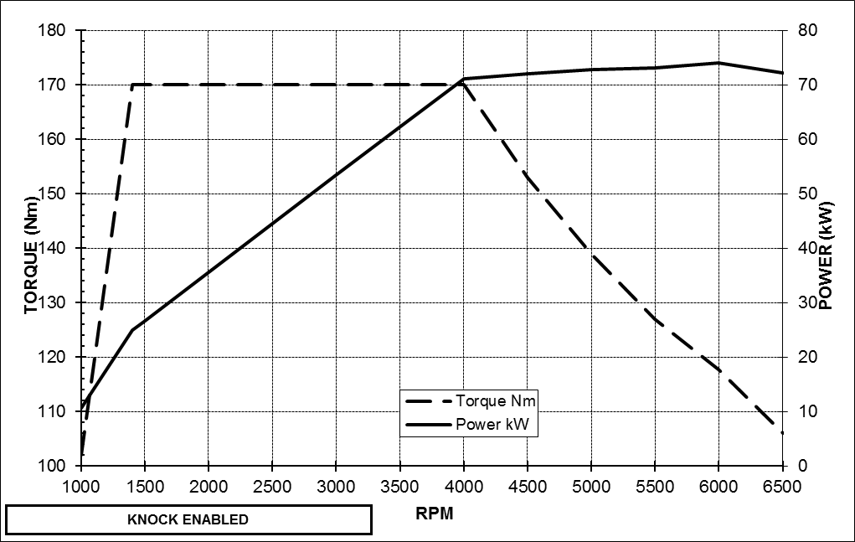

1.5-litre Duratorq TDCi 75PS (55kW)

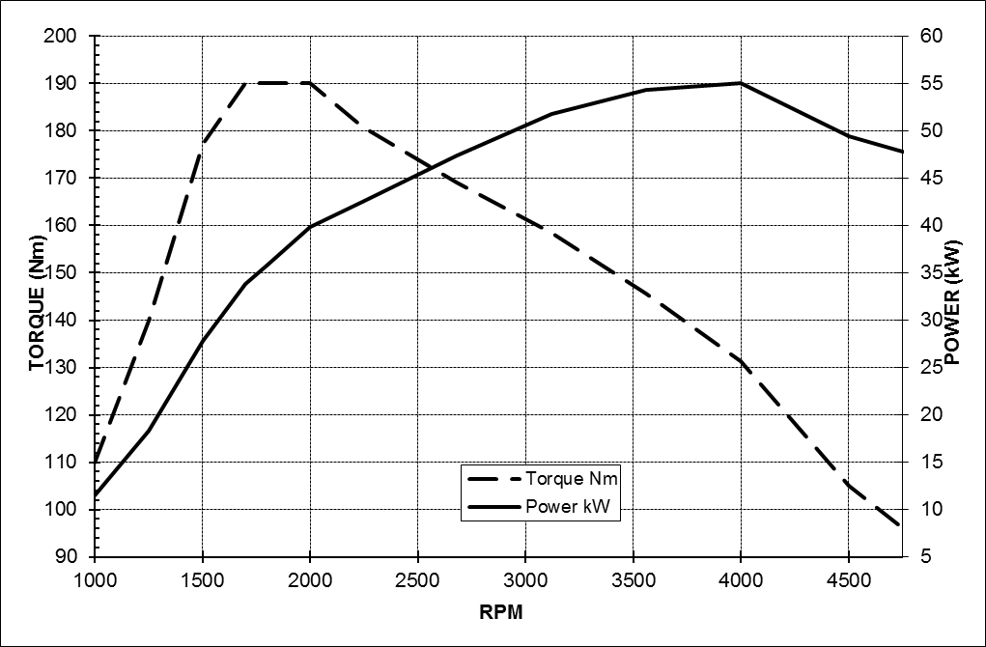

1.6-litre Duratorq TDCi 95PS (70kW)

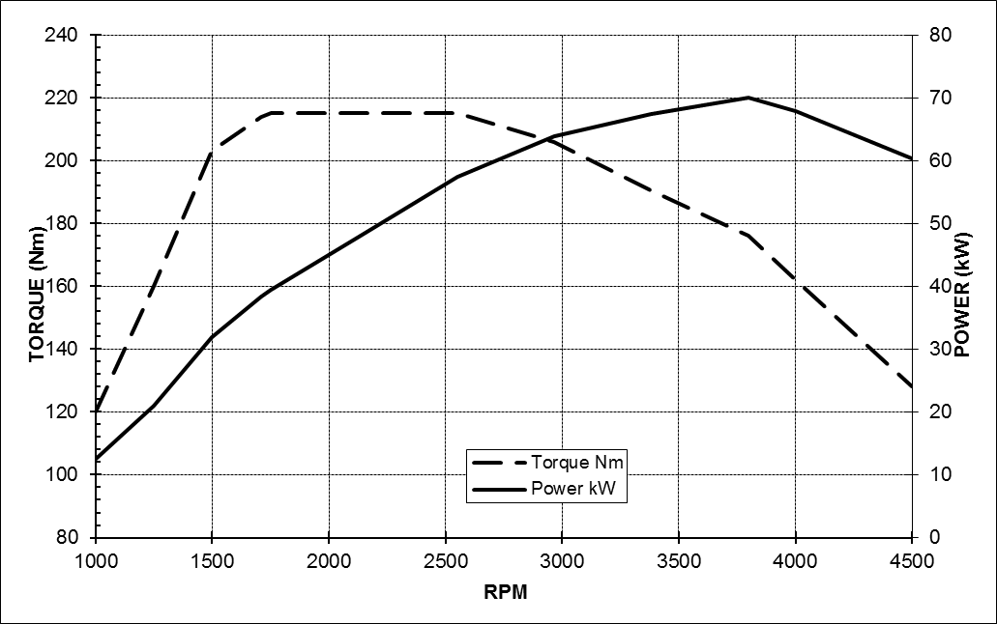

*Note: All fuel consumption and CO₂ emissions figures in g/km are from officially approved tests in accordance with EC Directive 93/116/EC. Fuel economy figures quoted are based on the European Fuel Economy Directive EU 80/1268/EEC and will differ from fuel economy drive cycle results in other regions of the world.

Note: The data information in this press release reflects preliminary specifications and was correct at the time of going to print. However, Ford policy is one of continuous product improvement. The right is reserved to change these details at any time.

About Ford Motor Company
Ford Motor Company, a global automotive industry leader based in Dearborn, Mich., manufactures or distributes automobiles across six continents. With about 181,000 employees and 65 plants worldwide, the company’s automotive brands include Ford and Lincoln. The company provides financial services through Ford Motor Credit Company. For more information regarding Ford’s products, please visit www.corporate.ford.com.

Ford of Europe is responsible for producing, selling and servicing Ford brand vehicles in 50 individual markets and employs approximately 47,000 employees at its wholly owned facilities and approximately 67,000 people when joint ventures and unconsolidated businesses are included. In addition to Ford Motor Credit Company, Ford Europe operations include Ford Customer Service Division and 22 manufacturing facilities (13 wholly owned or consolidated joint venture facilities and nine unconsolidated joint venture facilities). The first Ford cars were shipped to Europe in 1903 – the same year Ford Motor Company was founded. European production started in 1911.

Contact:
Detlef Jenter
Ford of Europe
+49 221 901 8745
djenter@ford.com

